Merchant documentation guide for SFCC REST Microform v2 upgrade

Contents
Step 1. Generate the server-side capture context 1
Step 2: Decode and Validate Capture Context 2
Step 3: Add clientLibrary and clientLibraryIntegrity values 4
Step 4: Load flex IFrame 5
Step 5: Replace diners-club with dinersclub 6
Step 6: Create Configurations 6

Step 1. Generate the server-side capture context
- Create a custom preference to add allowed networks for flex microform.
Refer section Create Configurations to create required configurations.
Go to Merchant Tools > Site Preferences > Custom Preferences > Cybersource_FlexMicroform and set values for the following parameters:
Set Cybersource_AllowedCardNetworks with the values that are allowed in flex microform service. If no card type is selected it would take Visa as default card type.
- Navigate to below path and add code changes to createFlexKey() method
Path: cartridges/int_cybs_sfra_base/cartridge/scripts/http/payments.js
var allowedCNetworks = dw.system.Site.getCurrent().getCustomPreferenceValue('Cybersource_AllowedCardNetworks');
var list =[];
if(empty(allowedCNetworks)){
list.push('VISA'); // if no card networks are added send Visa as default

}else{
for (let i = 0; allowedCNetworks[i]!= null ; i++) {
list.push(allowedCNetworks[i].value);
}
}

var publicKeyRequest = {
'encryptionType': Constants.ENCRYPTION_TYPE,
'targetOrigins':[
Constants.PROXY_PREFIX + '://' + request.httpHost
],
'allowedCardNetworks': list,
'clientVersion': Constants.CLIENT_VERSION
};

- Create constants for encryption type and client version
Path: cartridges/int_cybs_sfra_base/cartridge/apiClient/constants.js
/* Flex microform constants */
ENCRYPTION_TYPE: "RsaOaep256",
CLIENT_VERSION : "v2",
- Update below code to generate capture context for microform v2
Path: cartridges/int_cybs_sfra_base/cartridge/apiClient/api/KeyGenerationApi.js
Method: this.generatePublicKey
return this.apiClient.callApi(
'/microform/v2/sessions', 'POST',
pathParams, queryParams, headerParams, formParams, postBody,
authNames, contentTypes, accepts, returnType, callback
);
- Update ApiClient.js with below code to send response back
Path: cartridges/int_cybs_sfra_base/cartridge/apiClient/ApiClient.js
Method: CallApi method
if (response.ok) {
var responseObj = response.object;
if(path === '/microform/v2/sessions'){
callback(responseObj, false, response);
}else{
callback(JSON.parse(responseObj), false, response);
}
} else {
callback(response.errorMessage, response.error, response);
}

Step 2: Decode and Validate Capture Context
- Update controller with below code to call script and render template with required information.
Path: cartridges/int_cybs_sfra_base/cartridge/controllers/SecureAcceptance.js
server.get('CreateFlexToken', server.middleware.https, function (req, res, next) {
var Flex = require('~/cartridge/scripts/http/payments');
var flexResult = Flex.createFlexKey(); // call to create capture context
var parsedPayload = Flex.jwtDecode(flexResult); // parse capture context and validate public key
if(parsedPayload != null){ // extract client library as clientLibrary integrity values from capture context
var clientLibrary = parsedPayload.ctx[0].data.clientLibrary;
var clientLibraryIntegrity = parsedPayload.ctx[0].data.clientLibraryIntegrity;
res.render('secureAcceptanceFlexMicroformContent', { // add client library and client library integrity values dynamically
flexTokenResult: flexResult,
clientLibrary: clientLibrary,
clientLibraryIntegrity: clientLibraryIntegrity
});
next();
}
});

- Decode capture context:
Path: cartridges\int_cybs_sfra_base\cartridge\scripts\http\payments.js
// function to decode capture context and validate capture context using the public key
function jwtDecode(jwt){
var captureContext = jwt;
var Encoding = require('dw/crypto/Encoding');
var Signature = require('dw/crypto/Signature');
var Bytes = require('dw/util/Bytes');

var apiSig = new Signature();
var encodedHeader = captureContext.split('.')[0];
var encodedPayload = captureContext.split('.')[1];
var jwtSignature = captureContext.split('.')[2];

var kid = JSON.parse(Encoding.fromBase64(encodedHeader)).kid ;
var alg = JSON.parse(Encoding.fromBase64(encodedHeader)).alg;
var decodedPayload = Encoding.fromBase64(encodedPayload).toString();
var parsedPayload = JSON.parse(decodedPayload);
var decodedJwt = null ;

// generate public key using the kid from capture context
var pKid = getPublicKey(kid);

// Create public key using modulus and exponent value to validate capture context
var pkey = require('../http/publicKey');

if(!empty(pKid.n) && !empty(pKid.e)){
var RSApublickey = pkey.getRSAPublicKey(pKid.n, pKid.e);
var JWTAlgoToSFCCMapping = {
RS256 : "SHA256withRSA",
RS512 : "SHA512withRSA",
RS384 : "SHA384withRSA",
};
// validate capture context using the generated public key
var jwtSignatureInBytes = new Encoding.fromBase64(jwtSignature);
var contentToVerify = encodedHeader + '.' + encodedPayload;
contentToVerify = new Bytes(contentToVerify);
var isValid = apiSig.verifyBytesSignature(jwtSignatureInBytes, contentToVerify , new Bytes(RSApublickey) ,JWTAlgoToSFCCMapping[alg]) ;
if(isValid){
decodedJwt = parsedPayload;
}
}
return decodedJwt;
}

// Add below method to get public key by passing kid (extracted from capture context)

function getPublicKey(kid){
var cybersourceRestApi = require('../../apiClient/index');
var instance = new cybersourceRestApi.AsymmetricKeyManagementApi(configObject);
var jwk = '';
instance.getP12KeyDetails(kid, function (data, error, response) {
jwk = data;
})
return jwk;
}
- Update below code to generate public key
Path: cartridges/int_cybs_sfra_base/cartridge/apiClient/api/AsymmetricKeyManagementApi.js
Method: this.getP12KeyDetails
var accepts = ['application/json'];
return this.apiClient.callApi(
'/flex/v2/public-keys/{keyId}', 'GET',
pathParams, queryParams, headerParams, formParams, postBody,
authNames, contentTypes, accepts, returnType, callback
);
- Navigate to the path below in our cartridge and add this file to your custom cartridge. This will create a public key which is used to validate our capture context
Path: cartridges/int_cybs_sfra_base/cartridge/scripts/http/publicKey.js

Step 3: Add clientLibrary and clientLibraryIntegrity values
Update secureAcceptanceFlexMicroformContent.isml file as per the screenshot attached below.
Path: cartridges\int_cybs_sfra\cartridge\templates\default\secureAcceptanceFlexMicroformContent.isml
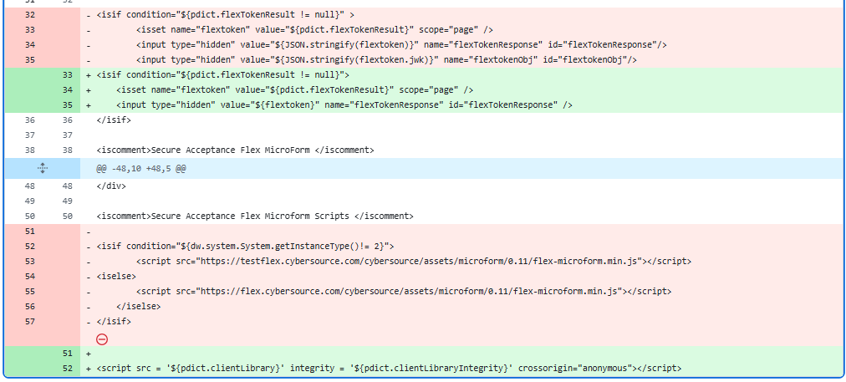

Step 4: Load flex IFrame
Path: cartridges\int_cybs_sfra\cartridge\client\default\custom\flexMicroform.js
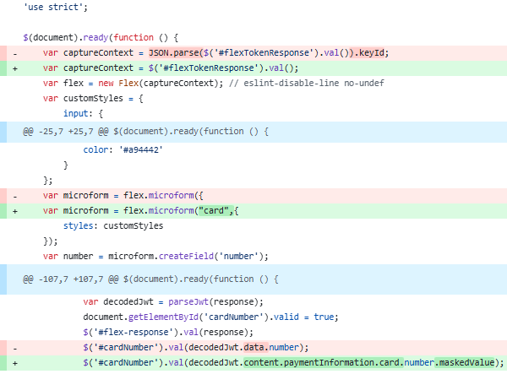

Step 5: Replace diners-club with dinersclub
Replace all the occurrences of diners-club with dinersclub in below files.
Path:
- cartridges/int_cybs_sfra/cartridge/client/default/custom/flexMicroform.js
- cartridges/int_cybs_sfra/cartridge/client/default/scss/components/_creditCardField.scss
- cartridges/int_cybs_sfra_base/cartridge/scripts/hooks/payment/processor/payments_credit_form_processor.js

Step 6: Create Configurations
Add below lines of code in FlexMicroform.xml and merged.xml files
Path:
- metadata\payments_metadata\meta\merged.xml
- metadata\payments_metadata\meta\FlexMicroform.xml
<attribute-definition attribute-id="Cybersource_AllowedCardNetworks">
<display-name xml:lang="x-default">allowedCardNetworks</display-name>
<description xml:lang="x-default">Configure card types for Cybersource Flex Microform</description>
<type>enum-of-string</type>
<mandatory-flag>false</mandatory-flag>
<externally-managed-flag>false</externally-managed-flag>
<select-multiple-flag>true</select-multiple-flag>
<value-definitions>
<value-definition default="true">
<display xml:lang="x-default">VISA</display>
<value>VISA</value>
</value-definition>
<value-definition>
<display xml:lang="x-default">MAESTRO</display>
<value>MAESTRO</value>
</value-definition>
<value-definition>
<display xml:lang="x-default">MASTERCARD</display>
<value>MASTERCARD</value>
</value-definition>
<value-definition>
<display xml:lang="x-default">AMEX</display>
<value>AMEX</value>
</value-definition>
<value-definition>
<display xml:lang="x-default">DISCOVER</display>
<value>DISCOVER</value>
</value-definition>
<value-definition>
<display xml:lang="x-default">DINERSCLUB</display>
<value>DINERSCLUB</value>
</value-definition>
<value-definition>
<display xml:lang="x-default">JCB</display>
<value>JCB</value>
</value-definition>
</value-definitions>
</attribute-definition>

<group-definitions>
<attribute-group group-id="Cybersource_FlexMicroform">
<attribute attribute-id="Cybersource_AllowedCardNetworks"/>
</attribute-group>
</group-definitions>

